Inlet Grove Community High School Governing Board Meeting Conference Room 102A

September 10, 2024 12:00 pm

Present:
- Dr. Charles Woodard, Chair
- Dr. Emma Banks, CEO
- La Voise Smith, Board Member
- Clarence Williams, Secretary
- Bill Washington, Treasurer
- Jim Pegg, Board Member
- George Lockhart, Board Member
- Monica Banks, Assistant Principal
- Francisco Lopez, Principal
- Annette Gardner, Consultant- Google Meet
- Anita Williamson, Bookkeeper/Finance
- Natacha Dominguez, Administrative Assistant

Absent:
- Lonnie Martens, Board Member
- Danny Jones, Board Member Welcome Opening: Dr. Woodard

Call to Order and Roll Call
The meeting commenced promptly at 12:00 PM, with all board members in attendance. The previous retreat minutes were presented for review. A motion to approve the minutes as written was made and seconded. The minutes were unanimously approved by the board.

Enrollment and Budget Overview
  - Current Enrollment: The principal reported that student enrollment stood at 718 students, short of the 800-student benchmark on which the school’s annual budget had been based.
  - Budget Shortfall: This enrollment gap has triggered adjustments to the school’s operating budget. The administration noted that salaries for certain staff members may need to be reevaluated, particularly those who were awarded pay raises contingent on higher enrollment.

Staff Reductions and Program Impact
  - Due to budget constraints, the school has had to reduce staff, including the termination of one English teacher and several other facilitators. The math facilitator’s position is also under review.

  - Academic programs, especially in journalism and other elective tracks, remain intact, but the administration stressed the importance of student retention within these programs.

Recruitment and Outreach Efforts: Chase Scott PR
  - A comprehensive recruitment campaign was launched to address the enrollment gap, targeting middle schools and families through social media, radio, and television ads.

Campaign Highlights: Chase Scott-PR
    - The campaign has focused on promoting the school’s Career Academy, journalism program, and a special “skip the 8th grade” track.
    - Ads were broadcast in both English and Spanish, and the campaign included direct outreach to more than 6,000 households.
  - Despite these efforts, 9th-grade enrollment was significantly below target, with only 163 freshmen enrolled, compared to the usual 259.

Facilities Update
  - Ongoing Expansion:
    - The administration provided updates on plans for facility expansion, which include a new football field, gymnasium renovations, and other improvements in partnership with the city.
    - Renderings of the new facilities will be developed and used in promotional materials to attract prospective students and enhance the school’s public image.

Budget Amendment Approval
The school’s Finance Support Consultant presented an amended budget proposal to account for the lower-than-expected student enrollment. Key points included:
  - FTE Adjustment: The school’s Full-Time Equivalent (FTE) count decreased from the budgeted 794.96 students to 788.77 students.
  - Revenue Impact: This decline in student numbers resulted in a revenue reduction of approximately $105,717.37.
  - Staffing Adjustments: Reductions in staff and changes in program allocations were required to bring the budget into balance.

4th Quarter FY 2023-2024 General Funds Amended Budget
  - FTE decreased 12.19; from 794.96 to 782.77; weighted FTE 788.7072.
  - Revenue is based on the FLDOE 2023-2024 FEFP Third Calculation.
  - Amend the budget and balance budget.
  - $105,717.37 decrease in revenue
  - $ 74, 537.36 increase in Industry Certification Funds.
  - Total revenue needed to balance budget ($31,180.01).
    - Bus Transportation increased $ 126,323.65.
    - A total of $ 65,578.92 various line items reallocated to 7800 Pupil Transportation Department to cover the overstated line item.
- A Total of $92, 035.61 of Reserve funds decrease to balance the budget.
- FY 2023-2024 Reserve balance $56, 372.00.
The motion to approve the 4th Quarter FY 2023-2024 General Funds Amended Budget, first motion by Jim Pegg and seconded by La Voise Smith, the motion carried without dissent and was approved by the governing board

4th Quarter ending 06/30/2024 Referendum Revenue and Expenditure Report
  - YTD revenue received $1,332,934.00 in addition to unexpended Funds from FY 2023 $41,409. Total $1,374,343.00.
  - YTD expenditures $ 1,023,284.00
  - Total Unexpended Funds from FY 2024 $ 351,059.
- The Board proceeded forward and motion to approve the 4th Quarter ending 06/30/2024 Referendum Revenue and Expenditure Report Motioned by La Voise Smith, seconded by Bill Washington. The motion was approved and carried without dissent by the governing board.

2024-2025 Referendum Revenue and Expenditure Plan
- Full Year Forecast
- Revenue $ 1,683,993.00
- Expenditures $ 1,601,167.00
- Remaining Revenue $ 82,826.00

4th Quarter GASB Year ending June 30, 2024, and Unaudited Balance sheet.
- Total Fund Balance $2,604,839.54
- Function number 7800 Pupil transportation services require a budget amendment.
  - The annual budget amended to $746,621.62
- Function number 9100 (9800 School Internal Funds) requires a budget amendment.
  - The annual budget was amended to $ 449, 128. 80
  - (Note page 3 of Special Funds of the Amended Budget) The board proceeded forward 4th Quarter GASB Year ending June 30, 2024, and
Unaudited Balance sheet. First Motion by Bill Washington Second motion by La Voise Smith. The motion was approved and carried without dissent by the governing board.

Fundraising and Corporate Sponsorships: Scott Chase- PR
  - The board discussed ongoing fundraising efforts, including outreach to corporate sponsors and alumni.
  - Special attention was given to enlisting the help of prominent alumni, such as Kansas City Chiefs coach Terry Braden, to aid in recruitment and sponsorship initiatives. The board expressed optimism about securing more financial support from businesses and private donors.

Strategic Planning for Future Enrollment
  - The board considered options for expanding the school’s grade levels from K-12 to create a sustainable student pipeline.
  - Board members acknowledged the complexity of such an expansion but emphasized its long-term benefits, particularly in creating a unified student culture and securing consistent enrollment.

Community Partnerships
  - The board discussed strengthening partnerships with local businesses. An agreement with the Rapids Water Park to provide job opportunities for students was highlighted as a successful example. These partnerships are seen as critical to integrating career training with real-world job placements for students.

Adjournment
The meeting concluded at approximately 1:20 PM. The board scheduled further discussions regarding recruitment strategies and financial planning for the next meeting October 15, 2024

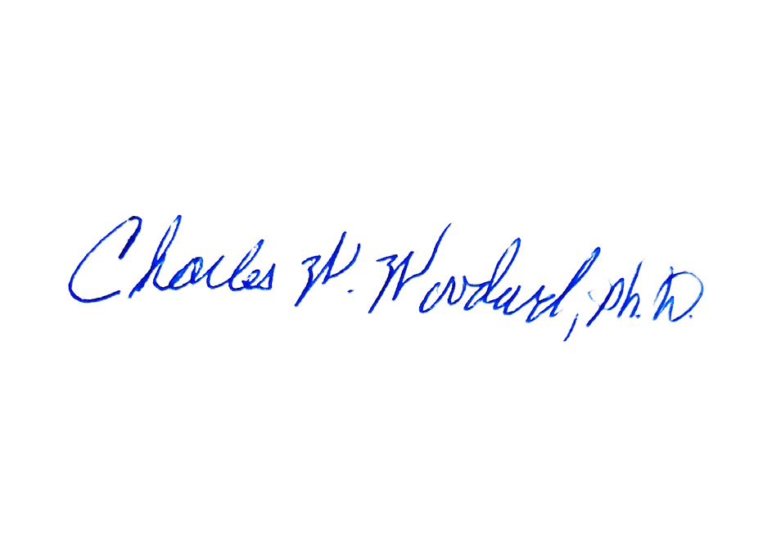
10/23/2024
12pm.
Dr. Charles Woodard,
Board Member Approving Signature
Date

