
a
Family Involvement Policy/Plan Summary
2026-2027
Parent involvement is a key factor in the academic success off all students at Inlet Grove Community Middle & High School
Inlet Grove Community Middle & High School
600 West 28th Street, Riviera Beach FL 33404
Phone: 561-881-4601
Fax: 561-881-4668
www.inletgrovehs.com


Shared Decision Making
Through the school’s Parent Teacher Association, parents will review and give input while writing the school’s Parent and Family Engagement Plan (PFEP) and evaluate the plan annually. Parents will also give input in writing the School-Parent Compact. Parents will review the Title I Family Involvement Survey data results to determine necessary changes. Use of parental involvement funds will also be discussed. Parents will receive information in a timely manner and will be informed of student curriculum and assessments. Parents will have opportunities to discuss school-wide programming and review data reports



Annual Title I Meeting
Parents are invited to attend this meeting at the beginning of each school year to learn more about the requirements of Title I and our school-wide Title I Programs. At this meeting there will be opportunities to review Title I documents and give input on the following:
- School-Parent Compact
- Title I Family Involvement Policy/Plan
- Parent’s Right to Know
- Ideas for future parent involvement activities
- Title I Budget

Communication
Parents will be provided information in a language and format which is easy to understand. We will communicate with parents by:
- Flyers and Inlet Grove School App
- SIS Parent Gateway
- School Website and E-mail
- Conferences
- Parent Link (Robo-phone calls)
- Visits by the Parent Involvement Liaison
- Family Involvement Surveys

Volunteers
Parents are encouraged to volunteer at our school in a variety of capacities that address the needs of the students and school.

Parent-Teacher organization (PTO)
Inlet Grove desires to create a PTO for the purpose of providing a communication and action organization for the parents of our students. If you are interested, please contact Mr. Grajek at thomas.grajek@pbcharterschools.org.

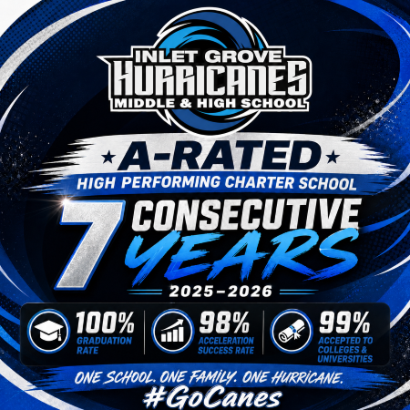

Parent Involvement Activities
Based on the parent survey input, we will provide the following activities to assist parents in understanding the state curriculum and assessments to help parents improve their children’s academic achievement:
- Title I Annual Meeting 8-27-26
- ELA & Mathematics Family Night 9-17-26
- College Family Night 10-22-26
- Credit and Financial Literacy Night 1-21-27
- Stem Family Night 3-11-2027

